Call for Solidarity with the Uprising of French Workers and Students
--Support June 14 General Strike
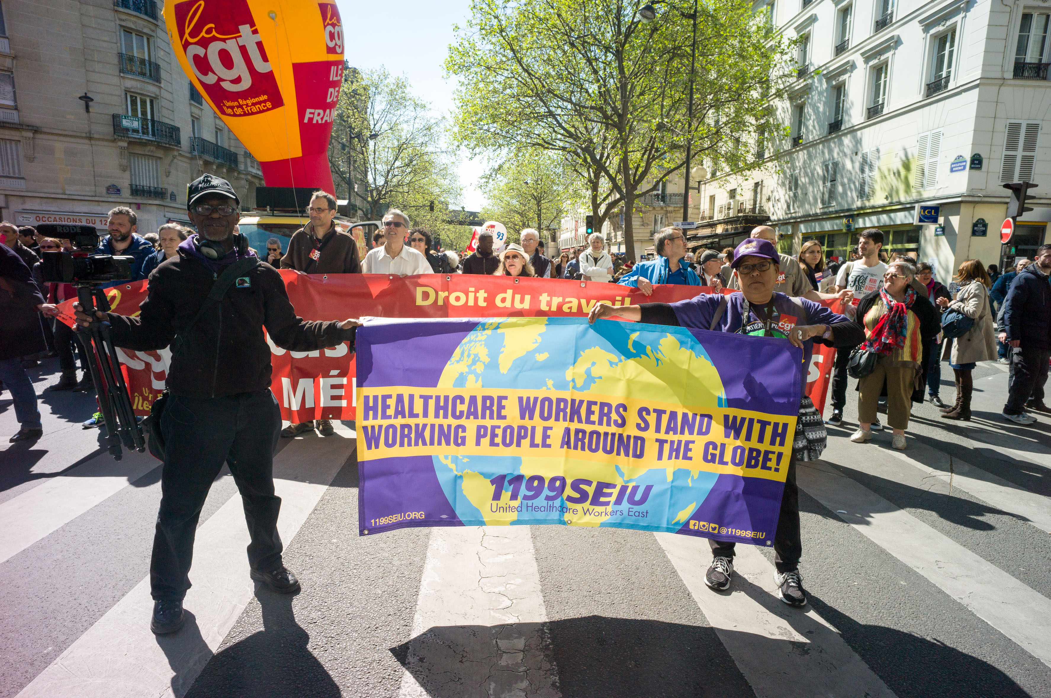
Part of U.S. delegation at Paris May Day march Photo @willyvainqueur
We, the undersigned, express our support for the ongoing mobilization of France’s workers in a coalition led by the General Confederation of Labor (CGT), and of the Nuit Debout movement consisting primarily of youth and students, against austerity attacks contained in that country’s so-called Labor Reform Law. This law, which was pushed through by the government and corporate vultures, will only serve to drive down the standard of living for current and future generations.
The demand to retain a 35-hour work week, with overtime paid after that, is part of the continuum that includes the often raised ‘30 hours work for 40 hours pay’ as a solution to unemployment in the U.S., and the current low-wage workers’ demand for $15 an hour and predictable scheduling.
The multinational French working class is using many forms of strikes, occupations and street protest, all of which illustrate who has the real power in society. On one day, no corporate newspapers were printed and on another, 40% of mass transit was shut down. This is happening despite the extension of a state of emergency (six months after the concert hall tragedy), the extreme militarization of the French police forces, and use of chemical gases--such as our sisters from SEIU 1199 and our brother from APWU suffered from while in Paris waiting to join the 2016 May Day parade.
We call on United States and other countries’ unions and other workers’ organizations, community groups and youth groups to exchange information with the French CGT and student leaders via satellite, radio, and written interviews with reliable translators. We further urge everyone to support the June 14 general strike in France via resolutions, educational meetings, and rallies at the nearest French consulate.
[Those of us in the New York City area intend to gather near the French Consulate at 934 5th Avenue that day between 4:00 and 6:00 p.m. EDT].
Signers as of June 4, 2016 (* = organization listed for identification only)
Andre Francois, President, United Steel Workers Local 8751, Boston School Bus Union (Massachusetts)
Chris Silvera, Secretary-Treasurer, International Brotherhood of Teamsters Local 808 (New York)
Pam Africa, International Friends and Family of Mumia Abu-Jamal
Martha Grevatt, Trustee, United Auto Workers Local 869*, Michigan
Wisconsin Bail Out The People Movement
Clarence Thomas, past Secretary-Treasurer of International Longshore & Warehouse Union Local 10*, San Francisco; Co-Chair of Million Workers’ March Movement
Dave Welsh, Delegate, San Francisco Labor Council*; Retiree, National Association of Letter Carriers Branch 214*
New York Peoples Power Assembly
Monica Moorehead & Lamont Lilly, 2016 Candidates of Workers World Party
Carl Gentile, labor consultant, Labor Union Advocates, LLC
Minnie Bruce Pratt, UAW Local 1981/National Writers Union*
Susan E. Davis, National Contract Advisor, Delegate, UAW Local 1981*
Pakistan USA Freedom Forum
Sue Harris, Ph.D., Co-Director, Peoples Video Network
Alberto Lovera Bolivarian Circle
Samidoun: Palestinian Prisoner Solidarity Network
Johnnie Stevens, Community-Labor United for Postal Jobs & Services
Joe Hirsch, Retiree, National Postal Mail Handlers Union Local 300*
Shirley Littman, Chelsea for Peace, New York City
Gregory Dunkel, Central Office Chapter Chair, Retired, Professional Staff Congress- City University of New York
Bill Dores, 2nd Secretary General, International League of Peoples’ Struggle
Myia X, Global Sisterz Media
Sharon Eolis, retired former Delegate, New York State Nurses Association*
John Catalinotto, Managing Editor, Workers World newspaper
Información al Desnudo 89.3FMDigital
Andre Powell, Workers World Party socialist candidate for Mayor of Baltimore
Picture the Struggle
Milt Neidenberg, Retired, Local 840 Teamsters*
Sara Flounders, International Action Center
Teresa Gutierrez, May 1st Coalition for Worker and Immigrant Rights
Steve Kirschbaum, Vice President, USW Local 8751/Team Solidarity
Fred Goldstein, author of Low-Wage Capitalism and Capitalism at a Dead End
Parents to Improve School Transportation
Mahtowin Munro, United American Indians of New England
Labor Against Racist Terror (Facebook page)
Benji Pyles, Appalachian Workers Alliance
Larry Holmes, First Secretary, Workers World Party
Brianca DJBrei Hawkins, disc jockey
Joe Friendly, Producer, Truth for a Change
Erica Mines of Philly Coalition for REAL (Racial, Economic and Legal) Justice

